Groups Management

Introduction
The Groups Management module allows administrators to create and manage groups, assign members, control permissions, and communicate effectively within groups. This helps in organizing members based on categories and improving targeted communication.

How to Access Groups Module
- Login to the system using Admin credentials.
- From the main menu, click Groups.

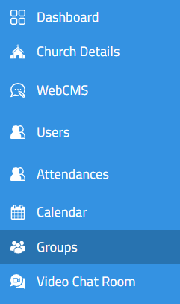

How to Create a New Group

Step-by-Step Procedure
- Click the New Group button.
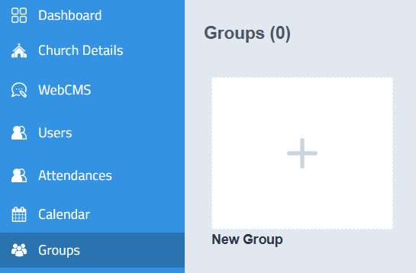
- A new group creation form will open.
- Enter the required details:
  - Select Category
  - Select Group Type
  - Group Name
  - Description
  - Upload Cover Image
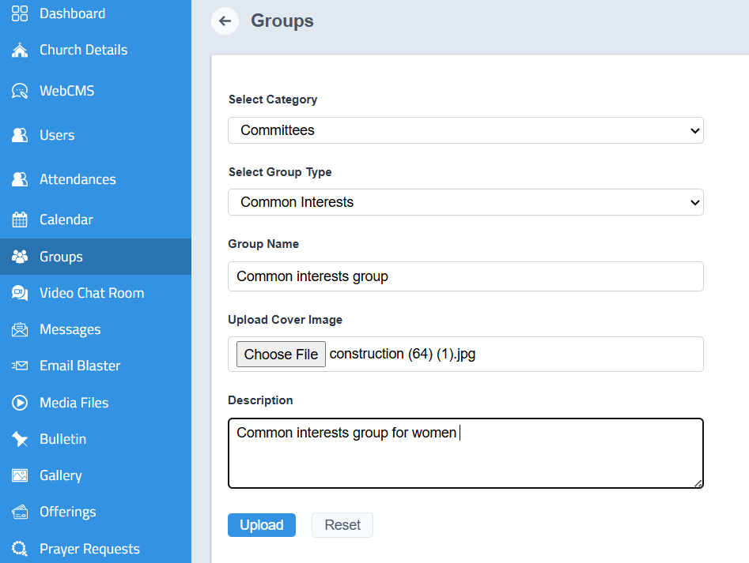
- Click Upload
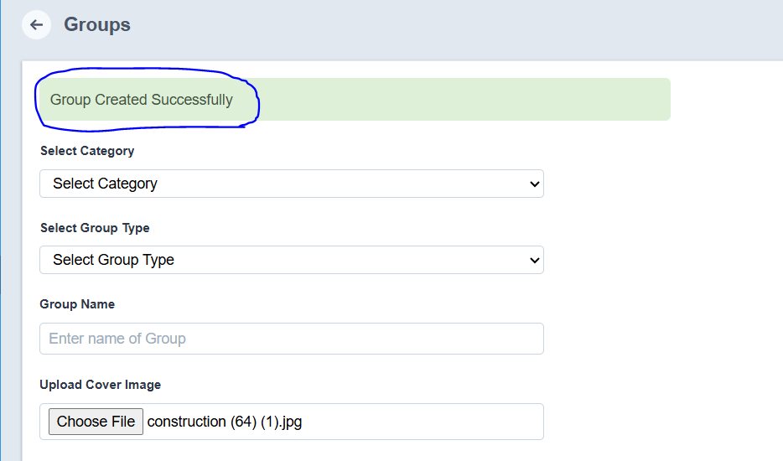

Outcome
- The group will be created successfully.
- It will be listed in the Groups module.

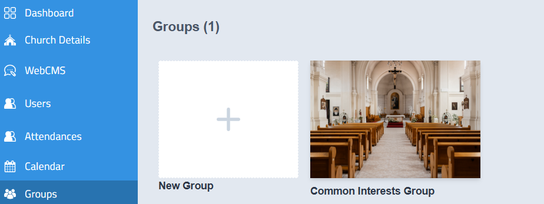

Viewing Group Details
- Click on the required Group Name.
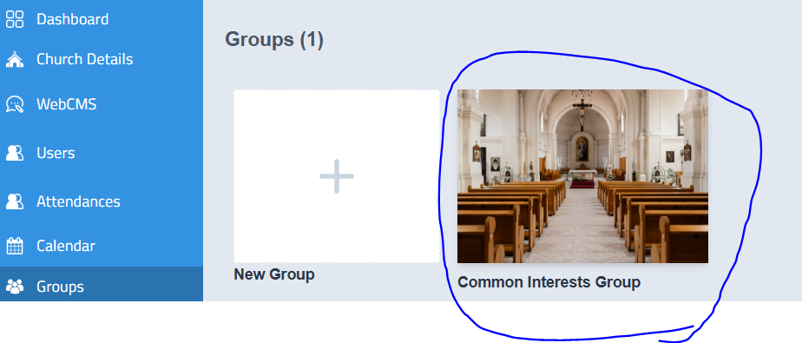
- The group details page will open.
- You can manage the group using the available options:
  - Add Members
  - Send Message
  - Message List
  - Edit Group
  - Delete Group

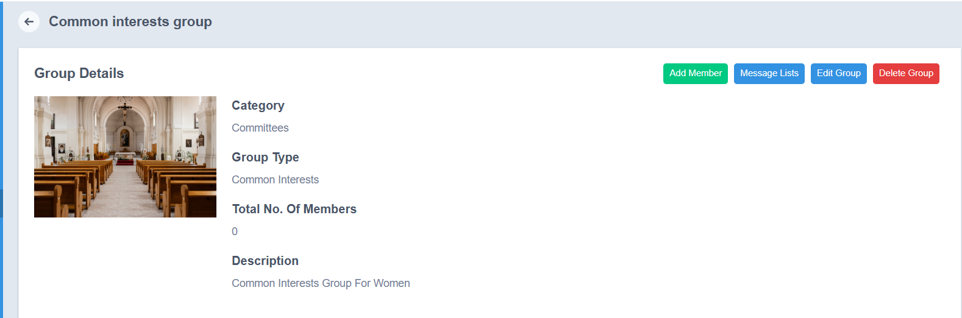

Add Members to a Group
- Click Add Members.
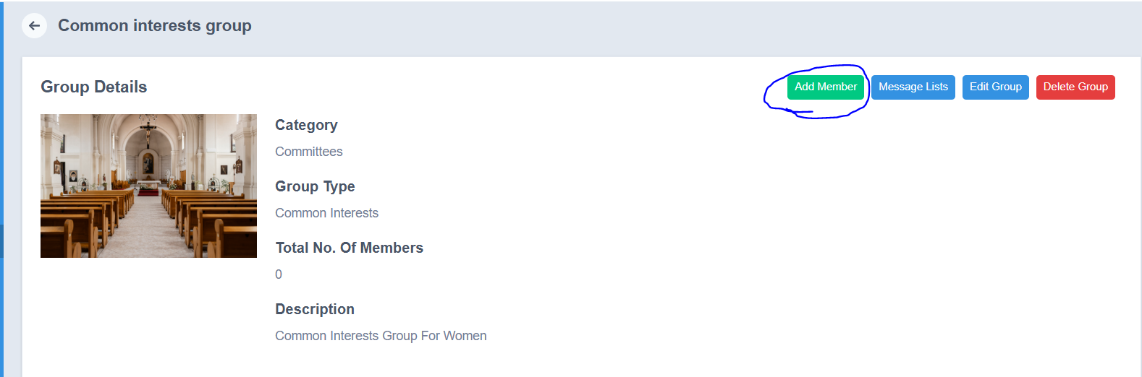
- Search and select members from the dropdown list.
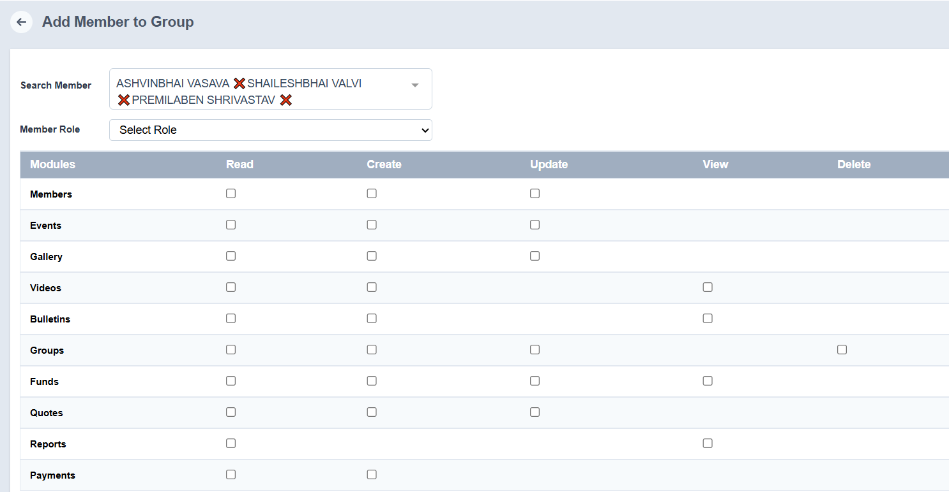
- Assign a Member Role.
- Set permissions by selecting authorization options:
  - Read
  - Create
  - Update
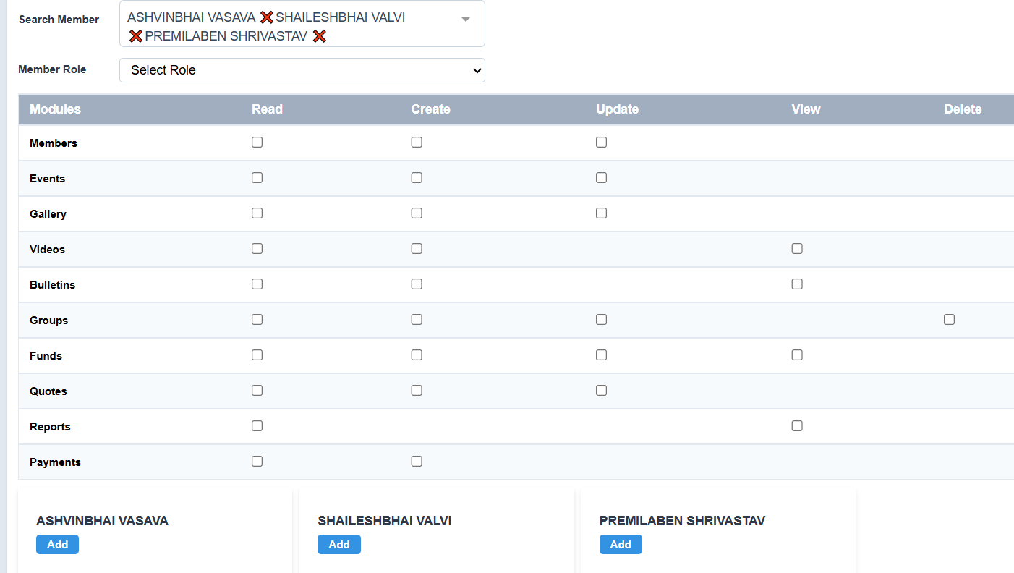
- Added members will be listed below.
- Click Submit.

Send Message to Group Members
- Click Send Message
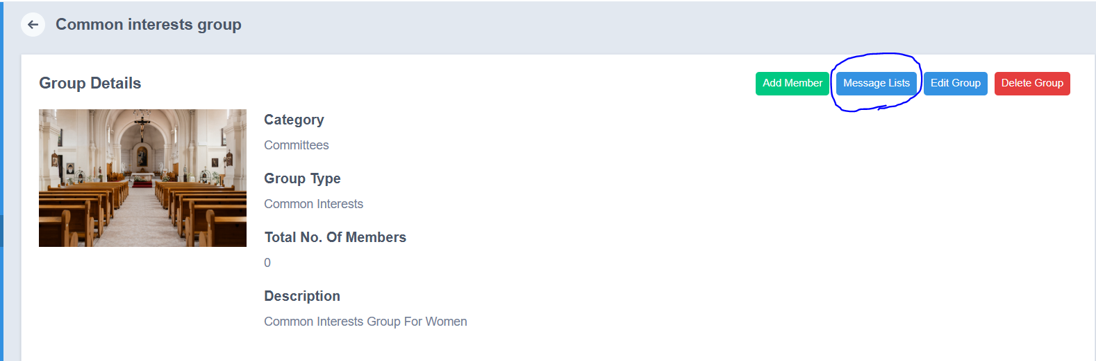
- Enter the required details:
  - Subject
  - Message
  - Attachments (if any)
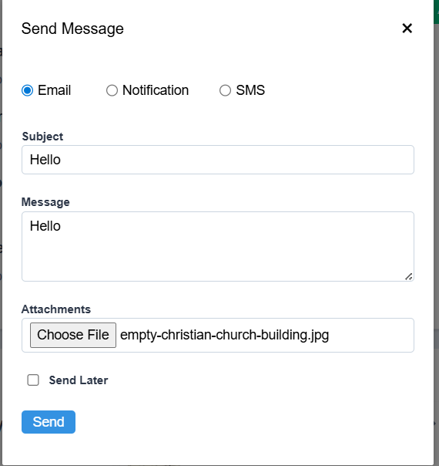
- Click Send.

Note
- Messages can be sent via:
  - Email
  - Notification
  - SMS

View Message List
- Click Message List.
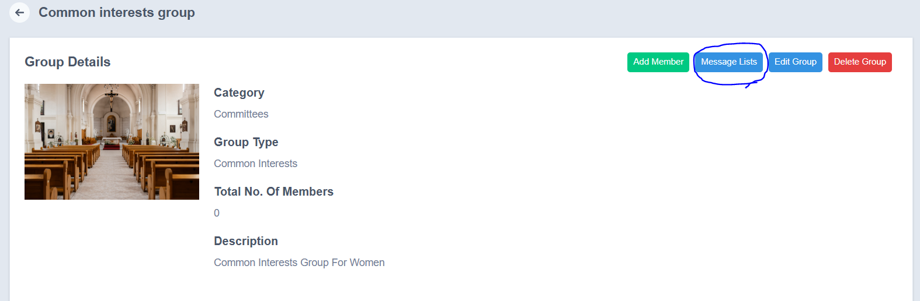
- View details such as:
  - Message Sent To
  - Mode (Email / Notification / SMS)
  - Sent On
  - Status
  - Action
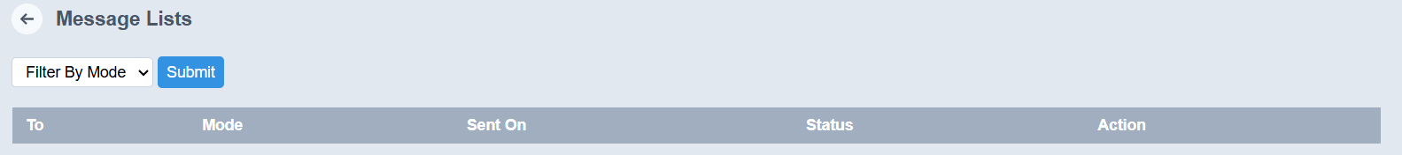

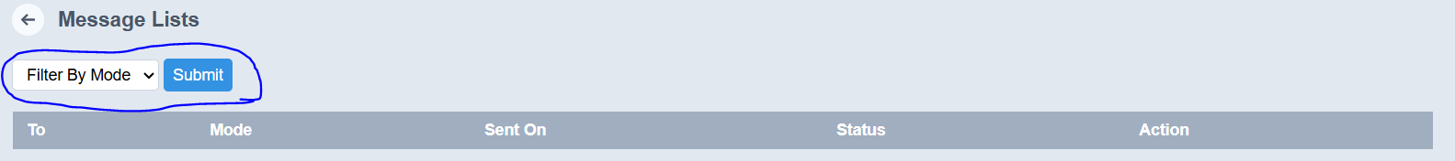

Note
- Messages can be filtered based on Mode.

Edit Group
- Click Edit Group.
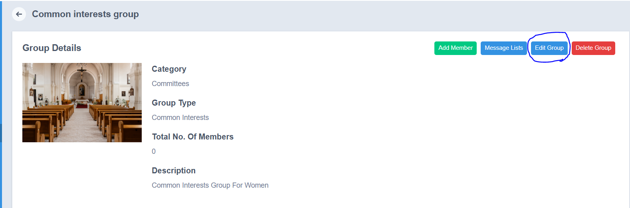
- Update required details such as:
  - Cover Image
  - Members (add/remove)
  - Roles and permissions
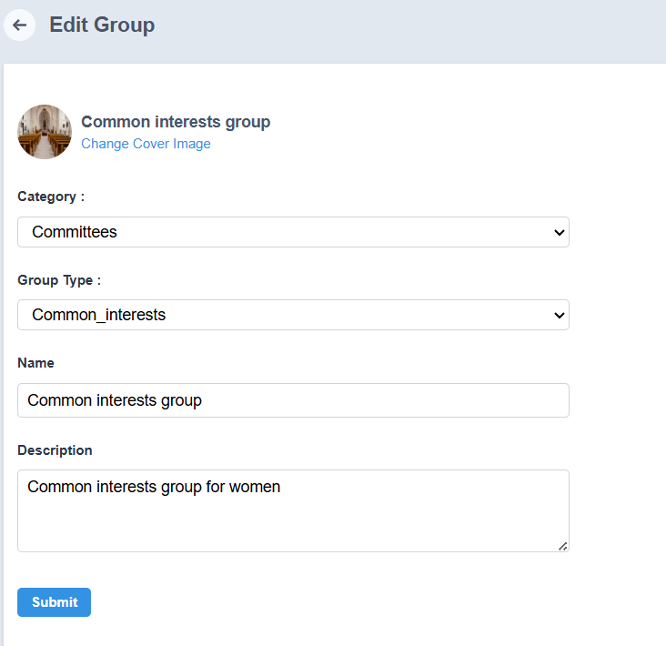
- Click Submit.

Delete Group
- Click Delete Group.
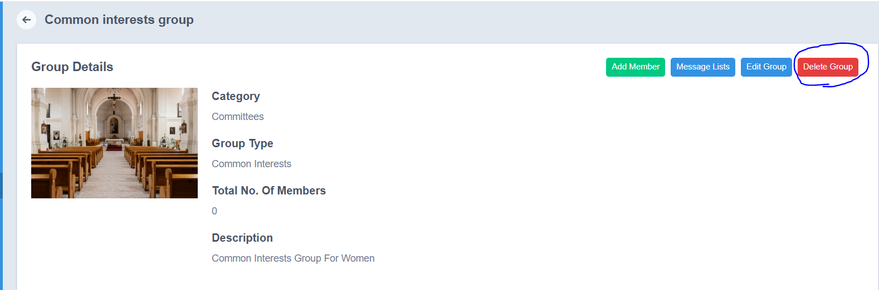
- Confirm the action.
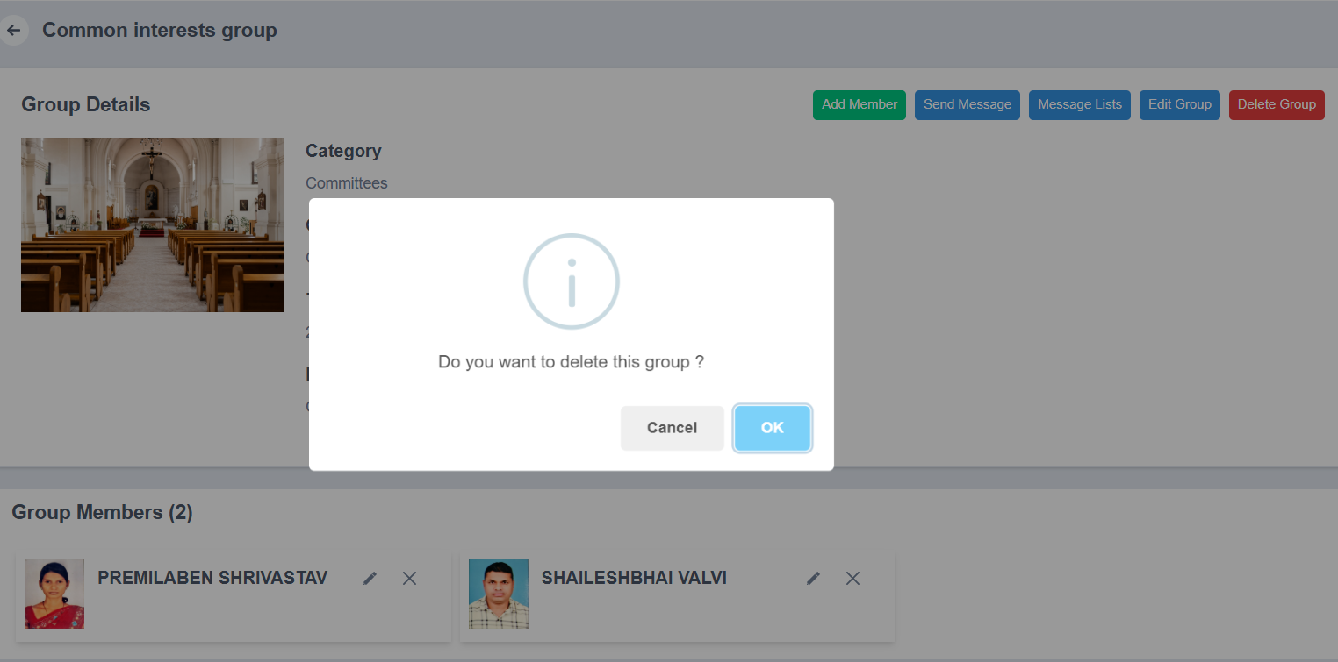
- The group will be deleted successfully.

Notes
- Ensure correct member roles and permissions are assigned.
- Deleting a group will remove all associated data and cannot be undone.

Conclusion
The Groups Management module helps streamline member organization, permission control, and communication, making group administration efficient and effective.

